Introduction to Ozone

What is ozone?
Ozone is a molecule made of 3 oxygen atoms. Ozone is produced both through naturally occurring processes, and also through processes that include man-made influences such as vehicle exhaust and industrial emissions.
Ozone occurs when an oxygen atom (O) is liberated from other molecules (sometimes these are already ozone molecules, sometimes they are other molecules that are often called ‘precursors’ for ozone) and combines/attaches itself to an oxygen molecule (O₂) to become an ozone molecule (O₃). This happens naturally in the stratosphere and results in a relatively even balance of ozone production and destruction, and the concentration generally stays about the same.
Here near the surface, man-made pollutants react in the presence of sunlight and lead to added production of ozone leading to unhealthy concentrations, and may cause damage to plants and animals (including humans) that encounter it.
Ozone can be “good” or “bad” depending on where it occurs in the atmosphere (Good up high, Bad nearby).

What does it (ozone) do? Why do we care about it?
All ozone is potentially hazardous to humans, plants, and animals if encountered directly—it causes heart and lung strain, and can irritate respiratory systems causing itchy or scratchy throat, coughing, and chest pain, and can aggravate pre-existing conditions such as emphysema, bronchitis, and asthma. The more ozone that a person breathes (high concentrations in short term exposure, or longer-term exposure even at lower concentrations) the more serious the effects can be; long lasting or even permanent damage is possible.
Ozone is mainly found in two places in the atmosphere: 1) at/near the surface 0-1 mi. Above Ground Level (AGL) where it decreases in concentration with altitude, and 2) in the stratosphere ~9-15 miles AGL where it increases in concentration with altitude.
(a)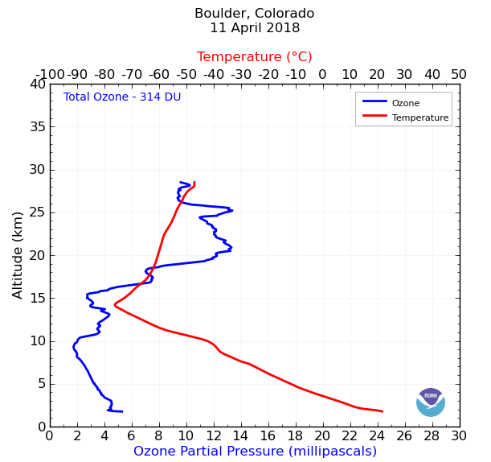
(b)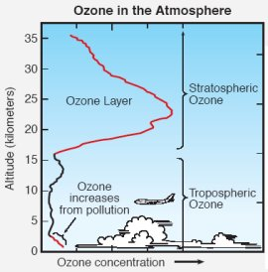

(a) An ozonesonde measures the amount of ozone at various levels in the atmosphere; this one was launched in Boulder, CO on April 11th, 2018; the Blue line is ozone concentration, red line is temperature (Source: https://www.esrl.noaa.gov/gmd/dv/iadv/graph.php?code=MFS&program=ozwv&type=vp);
(b) an idealized depiction of ozone in the atmosphere (source:https://www.airnow.gov/index.cfm?action=ozone_facts.index)

Ozone near the surface can hurt people, animals, and plants, but in the stratosphere ozone protects the lower atmosphere by interacting with harmful UV rays from the sun, and acts like ‘sunscreen’ for the earth.

What about an ozone hole?
The hole in the ozone layer is really no longer a ‘hole’ (if it ever truly was). There was significant thinning of the ozone layer, especially near the poles, during the late 70’s, 80’s and into the 90’s, caused by ozone-destroying chemicals that were used in many household products. These chemicals are now banned from use and heavily monitored (at least in the U.S.), and the stratospheric ozone layer is ‘healing’, returning to ‘normal’ concentrations and distributions in the stratosphere. There are still seasonal changes and scientists are always watching this to be sure that things are improving, but for now decreases in stratospheric ozone is not as great of a concern as it once was.

Ok, so ozone near the ground is bad, and ozone up high is good (Good up high, bad nearby). Why don’t we just put all the low level ozone up in the stratosphere?
There is a layer of the atmosphere in between the troposphere (the lowest layer, where we live) and the stratosphere (the second lowest major layer) called the tropopause. This thin layer acts like a barrier between these two regions of atmosphere and slows down the mixing of air in between these layers. This mechanism is what naturally keeps most of the ozone in the stratosphere, and is generally a good thing. However the plain fact of this layer’s existence is also what would make it very difficult to transport ozone for the sole purpose of decreasing surface concentrations. Because of this, it would be prohibitively costly to transport the ozone (and only the ozone) from the surface to the stratosphere.

What else can we do to keep the ‘Good’ ozone where we want it and the ‘Bad’ ozone out of where we don’t?
The main way to do this is by helping to prevent the creation of ground-level ozone, and preventing the destruction of stratospheric ozone. By being sure that appliances like air conditioners and refrigerators are in proper working order (not leaking chemicals harmful to ozone) we can stop the damage that has been done to the ozone layer and allow it to repair itself, as it is already doing. This will help to maintain the ‘good’ ozone in the stratosphere, where we want it to be.
By following some Simple Steps. Better Air. guidelines (see the list below) there are many ways to work toward the goal of limiting or preventing harmful concentrations of ‘bad’ ozone at low levels, where it is harmful to our health.

What can I do to protect myself from any and all ozone’s negative health impacts?
Awareness is a good start. When ozone is high, simply reducing vigorous activity will help to reduce the amount that you breathe. Additionally, going inside can help to protect you as many indoor air filters will help to ‘break-up’ ozone and neutralize its negative effects. Alternatively, hold off on those more active pastimes until evenings, or get up early to exercise and help to avoid the high-ozone parts of the day.

Can we prevent the bad ozone?
Yes, there are many small ways that we all can help to change daily activities that will help reduce the presence of ozone precursors—those chemicals that can react in the presence of sunlight and create ground-level ozone. See the list of suggestions below.

Simple Steps. Better Air.
simplestepsbetterair.org

Start with fewer car trips—Skip the Trip!
- Pack a lunch or walk to lunch
- Walk, jog, or ride a bike to the gym
- Use Public Transit to get to a game, concert, or other event
- Shop for items online
Combine Car trips
- Adopt the “while I’m out” approach
- Pick one day to run errands, and put an errand box in your car with reminders so you don’t forget
- Try to keep trips to 30 minutes or less
Combine Passengers on Trips
- Make new friends
- Gas savings
- Don’t have to find a parking spot
- Use HOV lanes
Take Public Transportation
Energize Your Ride
- Consider electric vehicles
Take Steps at Home
- Use low VOC cleaners, paints, and other household products
- Keep lawn equipment well maintained or switch to electric tools
- Mow after 5 pm on hot, sunny, summer days
Challenge yourself to add other efforts
- Don’t let your car idle for more than 30 seconds
- Fill your gas tank in the evening when it’s cool
- Stop refueling at the click
- Keep your car well-tuned

